

Werewolves

This document is a proposal of project to be accepted by the Tokiota Web and Mobile Community as a working item.

Tokiota Web & Mobile Community

**Sílvia Mur Blanch**

silvia.mur@tokiota.com

|  |  |
| --- | --- |
| C:\Users\smur\Pictures\Werewolves-of-Millers-Hollow.png | *“Miller’s Hollow hides a terrible secret: there are werewolves living amongst its people, and they haunt and kill the villagers by night. Are you a werewolf, or a villager?”* |

# Introduction

*Meteor* is a [free and open-source](https://en.wikipedia.org/wiki/Free_and_open-source_software) [JavaScript](https://en.wikipedia.org/wiki/JavaScript) [framework](https://en.wikipedia.org/wiki/Web_framework) written using [*Node.js*](https://en.wikipedia.org/wiki/Node.js). *Meteor* allows for rapid prototyping and produces cross-platform code (web / Android / iOS). It integrates with [*MongoDB*](https://en.wikipedia.org/wiki/MongoDB) and uses the [Distributed Data Protocol](https://en.wikipedia.org/wiki/Distributed_Data_Protocol) and a [publish–subscribe pattern](https://en.wikipedia.org/wiki/Publish%E2%80%93subscribe_pattern) to automatically propagate data changes to clients without requiring the developer to write any synchronization code. On the client, *Meteor* depends on [*jQuery*](https://en.wikipedia.org/wiki/JQuery) and can be used with any JavaScript UI widget library.

*Werewolves of Miller’s Hollow* is a party game that takes place in a small village which is haunted by werewolves. Each player is secretly assigned a role - Werewolf, Ordinary Townsfolk, or special character such as the Sheriff, the Hunter, the Witch, the Little Girl, The Fortune Teller and so on... There is also a Moderator player who controls the flow of the game. The game alternates between night and day phases. At night, the Werewolves secretly choose a Villager to kill. During the day, the Villager who was killed is revealed and is out of the game. The remaining Villagers then deliberate and vote on a player they suspect is a Werewolf, helped by the clues the special characters add to the general deliberation. The chosen player is "lynched", reveals his/her role and is out of the game.

My proposal is to create a *Werewolves* game web app that can be played through your smartphone (or any other web-enabled device). This web app will be developed using *Meteor*, in order to take advantage of its amazing data synchronization feature.

The *Werewolves* web app only eliminates the necessity of having the game cards physically; the flow of the game is exactly the same and the Moderator is still necessary. These are the keys to the web app:

* First and foremost, all players need to login in order to provide a username and unique identifier
* The person creating the game will be the Moderator
* Players can join already created games by just providing an existing game code
* Once all players have joined the game, the roles are randomly and automatically assigned by the app
* Players may place their smartphone in front of them during the game
* The Moderator will have a special dashboard with which she will update the status of the game
* Player deaths will be notified through their smartphones, next revealing their identities

# Main Functionalities (initial phase)

* Develop a home screen where a new game can be created, or an existing game can be joined
* Develop a screen to create a new game, where the Moderator will:
  + Choose which special characters take part in the game
  + Choose how many werewolves take part in the game (4 tops)
  + Start the game by clicking a button
* Develop the game start process, where characters are randomly and automatically assigned to each logged in player. Each player then receives a picture of their assigned character in their device. When clicking on the picture, it will be flipped so that their identity remains secret
* Develop the Moderator’s dashboard:
  + It displays all the players’ cards
  + Clicking on a card/player means given player is chosen to die (either lynched by angry mob or killed by werewolves). A final step (clicking on a button) is required to confirm the death
  + When a player is killed, given player is notified and his identity is revealed

# Technologies and Frameworks

* JavaScript
* Meteor
* MongoDB

# Wireframes

## Login

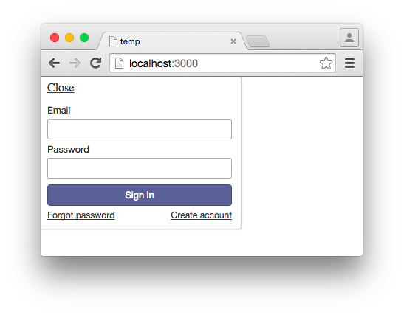

## Moderator’s path

|  |  |
| --- | --- |
|  |  |

|  |  |
| --- | --- |
|  |  |
|  |  |
|  |  |

Player’s path

|  |  |
| --- | --- |
|  |  |
|  |  |
|  |  |

# Future Improvements

* Create smartphone application
* Add ambient sounds to the game (wolf howl, creepy night sound, rooster’s crowing, etc.)
* Add more special characters to the game (Cupid, Captain, Thief, etc.)
* Add more features to the Moderator’s dashboard
* Add feature to allow players to vote for the next player to be killed off during the day phase through their dashboard
* Add score boards & statistics